Shark Analysis Toolbox

The static conditions of the sharks ensemble is measured through a semi-automated solution able to accurately locate the individuals in colour images, not only in terms of position, but orientation as well. With this information some well known metrics such as distance between individuals and alignment can be easily extracted automatically. Thus, the operation of this toolbox is performed in two phases, namely labeling and analysis.

The first phase needs of user interaction given the challenging conditions found in the images. In our case, these are independent images acquired from mobile devices such as drones where the whole scene moved from one frame to another, making unsuitable the application of techniques such as background removal to isolate the sharks. On top of that, the low contrast between sharks and the background posed a challenging issue for other techniques such as thresholding. Finally, our approach do not require of great amounts of data as in machine learning proposals. Therefore, our approach is suitable for analysis conditions with a reduced number of frames.

The toolbox has been developed using a commercial software package MATLAB [1].

* 1. Shark Labeling

The first phase of the execution expects as input top view images containing individuals as shown in Figure 1. The user will see first a window displaying the input image containing sharks. To alleviate the process of labeling the initial image area can be cropped, adjusting it to the area of interest containing the individuals. Next, an iterative process starts in which the cropped area is decomposed into sub-images that are magnified in order to allow a more accurate labeling. In each sub-image, the user locates the individuals by clicking on the most distant points of the fish, tip of the head (Hx,Hy) and tip of the tail (Tx,Ty). This will provide, for each individual, its central position as the mean of those two points (Cx,Cy), and the swimming orientation (*u,v*) (see Figure 2). Since we are working with still images, the swimming speed cannot be calculated. Thus, we fixed the magnitude of the *(u,v)* vector to the labeled shark length although this parameter could be set as constant since in this work we are interested on orientation.

Once all sharks in a sub-image are labeled, the process continues until the whole cropped area has been scanned.

This process results in the information shown in Table 1. As no information apart from the one contained in the image is available, the measuring units are pixels. Note that despite the user labels sharks contained in the sub-windows, the final positions are output with respect to the origin of coordinates of the initial image, with the (0,0) position corresponding to the upper left corner.

|  |  |  |  |  |  |  |  |
| --- | --- | --- | --- | --- | --- | --- | --- |
| ***Tx*** | ***Ty*** | ***Hx*** | ***Hy*** | ***Cx*** | ***Cy*** | ***u*** | ***v*** |
| 55,28 | 1,79 | 57,04 | 22,36 | 56,16 | 12,08 | 20,57 | 1,76 |
| 197,50 | 80,55 | 149,31 | 86,43 | 173,41 | 83,49 | 5,88 | -48,19 |
| 127,57 | 138,73 | 111,70 | 176,35 | 119,63 | 157,54 | 37,61 | -15,87 |

Table 1. Shark labeling output. Each row contains the attributes of a single labeled shark.

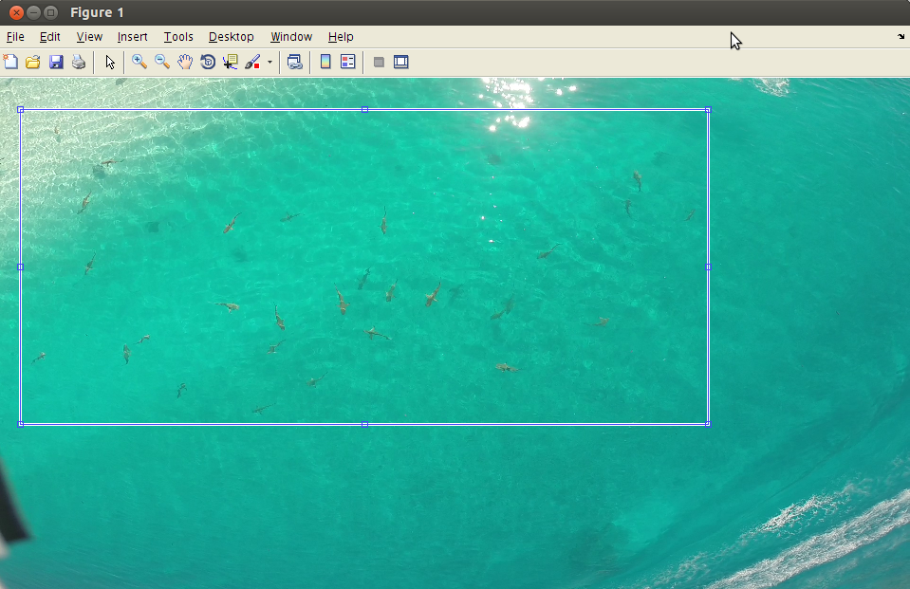

Figure 1. Input image for the algorithm. The highlighted rectangle shows the area of interest selected by the user to apply the labeling process.

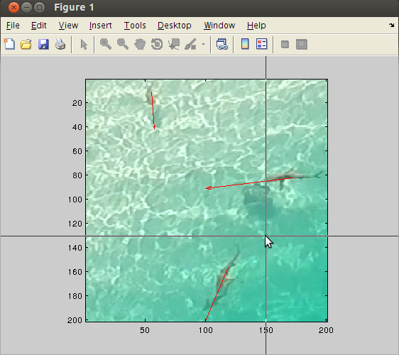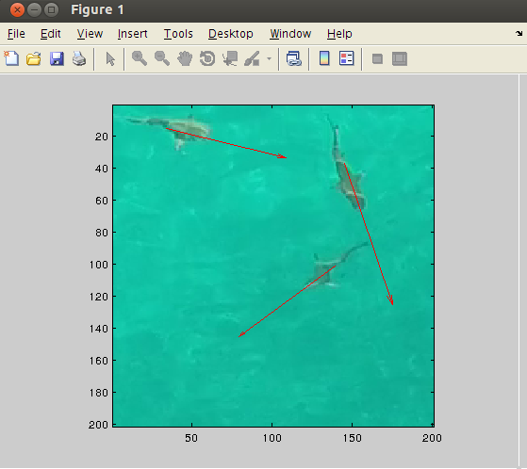

Figure 2. Samples of labeling windows containing sharks.

* 1. Shark Analysis

The second phase uses as input values with the format shown in Table 1, analyzing them to assess whether or not there is a degree of the alignment and compactness that indicates schooling behavior.

The first step is to compute the nearest neighbor to each labeled shark using the central position (Cx,Cy) to assess the distance between individuals. Thus, for each shark central position, the Euclidean distance towards all labeled sharks is calculated, keeping the index of the individual that minimizes such distance.

Once the nearest neighbors are established, the algorithm calculates the alignment between neighbors using the swimming orientation (u,v) and the magnitude of the vectors for comparison. From these values, the alignment can be calculated using the Dot Product:

where and are the vectors defining the swimming orientation of two neighbor sharks, and are the magnitudes (lengths) of the vectors and is the angle (in degrees) between and .

The last part of the analysis involves assessing the compacity and alignment (if any) of the school of sharks. For this purpose, first we define some thresholds to

Calculate the mean body length (in pixels) from the labeled sharks as the median of all lengths, Ls.

where n is the number of labeled sharks. Next, the median, , is calculated as the value of the sorted series, Ls. A conservative threshold, , is calculated from this value as 2 times .

Therefore, values below this threshold will be considered as individuals schooling with their nearest neighbor.

Following the same idea, the median angle, , is used as threshold to assess whether two sharks are aligned.

Figure 4 shows the output of the algorithm in which information has to be interpreted in two ways: on the one hand, asterisks signal the central position (Cx,Cy) of each shark. Such position is plotted either in red or blue depending on whether the distance to the closest neighbor is below the threshold. The arrows in the image represent the swimming direction of each individual. Since angle between neighbors are directly obtained from their respective swimming directions, the figure shows the alignment toward the nearest neighbor as a red arrow if the angle between neighbors is below the threshold , and as a red arrow otherwise.

Finally, Table 2 shows the results of both the labeling and analysis processes with all derived information resulted from applying the process to Figure 1.

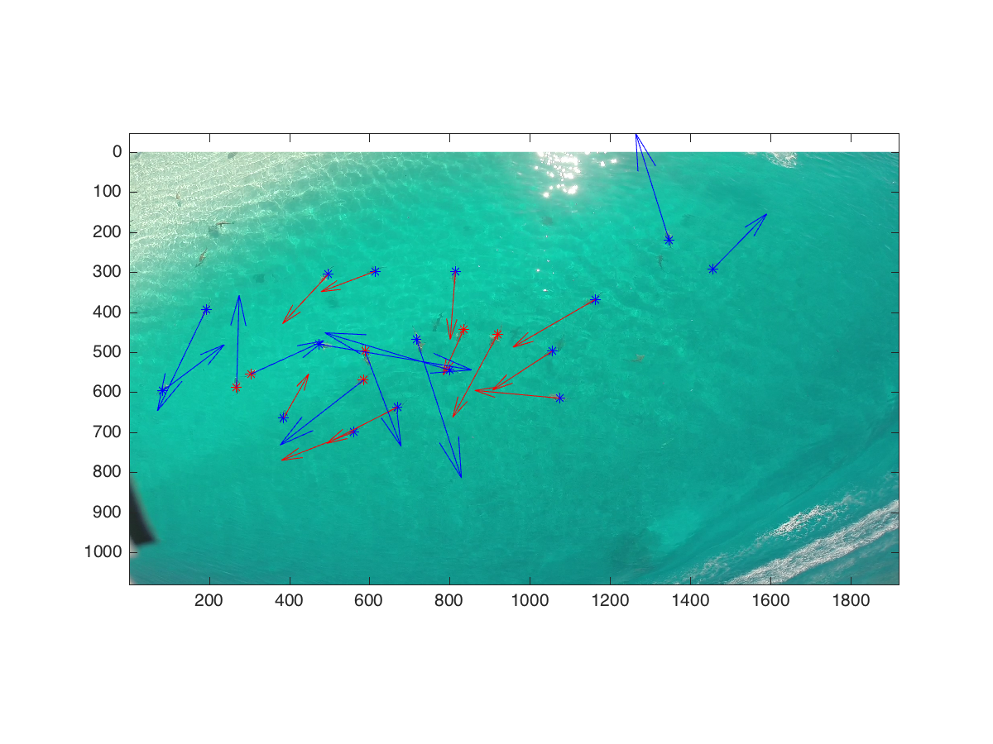

Figure 4. Result of the analysis. Red asterisks indicate proximity with the closest neighbor. Red arrows indicate alignment with respect to the closest neighbor.

|  |  |  |  |  |  |  |  |  |  |  |  |
| --- | --- | --- | --- | --- | --- | --- | --- | --- | --- | --- | --- |
| **Shark**  **id** | **Tx** | **Ty** | **Hx** | **Hy** | **Cx** | **Cy** | **u** | **v** | **Neighbour**  **id** | **Neighbour**  **distance** | **Neighbour**  **Angle** |
| 1 | 484,71 | 170,56 | 453,65 | 203,97 | 469,18 | 187,26 | 33,402 | -31,058 | 2 | 116,25 | 26,408 |
| 2 | 603,43 | 173,07 | 566,98 | 186,82 | 585,21 | 179,95 | 13,753 | -36,446 | 1 | 116,25 | 26,408 |
| 3 | 787,85 | 156,5 | 784,33 | 202,79 | 786,09 | 179,65 | 46,294 | -3,516 | 10 | 145,89 | 20,019 |
| 4 | 1326,9 | 126,03 | 1311,7 | 77,388 | 1319,3 | 101,71 | -48,638 | -15,236 | 5 | 131,21 | 61,719 |
| 5 | 1416,6 | 186,38 | 1441,2 | 161,19 | 1428,9 | 173,79 | -25,198 | 24,612 | 4 | 131,21 | 61,719 |
| 6 | 175,54 | 251,6 | 153,28 | 297,9 | 164,41 | 274,75 | 46,294 | -22,268 | 16 | 196,19 | 140,21 |
| 7 | 410,88 | 355,91 | 480,61 | 367,63 | 445,74 | 361,77 | 11,72 | 69,735 | 8 | 116,48 | 59,734 |
| 8 | 552,69 | 357,67 | 569,1 | 401,03 | 560,89 | 379,35 | 43,364 | 16,408 | 19 | 71,91 | 72,851 |
| 9 | 678,85 | 317,82 | 699,36 | 381,11 | 689,11 | 349,47 | 63,289 | 20,51 | 21 | 112,27 | 124,6 |
| 10 | 814,39 | 308,45 | 800,33 | 339,5 | 807,36 | 323,98 | 31,058 | -14,064 | 11 | 85,32 | 4,0805 |
| 11 | 906,98 | 308,45 | 876,51 | 364,7 | 891,74 | 336,57 | 56,257 | -30,472 | 10 | 85,32 | 4,0805 |
| 12 | 1047,8 | 365,87 | 1007,4 | 392,24 | 1027,6 | 379,06 | 26,37 | -40,434 | 22 | 118,91 | 38,358 |
| 13 | 1162,9 | 234,1 | 1107,2 | 266,38 | 1135 | 250,24 | 32,282 | -55,703 | 12 | 167,76 | 3,0171 |
| 14 | 41,934 | 488,52 | 70,063 | 467,43 | 55,999 | 477,97 | -21,096 | 28,128 | 15 | 184,36 | 51,539 |
| 15 | 239,59 | 490,87 | 240,76 | 448,67 | 240,18 | 469,77 | -42,192 | 1,172 | 16 | 48,71 | 63,889 |
| 16 | 258,93 | 443,99 | 292,33 | 428,75 | 275,63 | 436,37 | -15,236 | 33,402 | 15 | 48,71 | 63,889 |
| 17 | 349,17 | 560,6 | 366,17 | 530,71 | 357,67 | 545,66 | -29,886 | 16,994 | 16 | 136,66 | 35,857 |
| 18 | 557,96 | 570,56 | 508,74 | 589,9 | 533,35 | 580,23 | 19,338 | -49,224 | 20 | 124,95 | 5,6736 |
| 19 | 576,19 | 436,33 | 538,04 | 466 | 557,11 | 451,16 | 29,677 | -38,156 | 8 | 71,91 | 72,851 |
| 20 | 665,96 | 506,1 | 617,91 | 530,71 | 641,93 | 518,41 | 24,612 | -48,052 | 19 | 108,24 | 10,754 |
| 21 | 799,57 | 434,61 | 742,73 | 417,62 | 771,15 | 426,11 | -16,994 | -56,843 | 10 | 108,37 | 82,283 |
| 22 | 1075,3 | 499,07 | 1017,9 | 493,8 | 1046,6 | 496,43 | -5,2741 | -57,429 | 12 | 118,91 | 38,358 |

Table 2. Main features extracted from the labeling and analysis.

* 1. References

[1] MATLAB and Statistics Toolbox Release 2012b, The MathWorks, Inc., Natick, Massachusetts, United States.